Interactive Media ExploreDigest as an Innovation in Human Digestive System Learning within the Stream of Sustainable Education

Dwi Ratna Sulistyowati*
Department of Primary Education, State University of Surabaya, Surabaya, Indonesia

Suryanti
Department of Primary Education, State University of Surabaya, Surabaya, Indonesia

Wahono Widodo
Department of Science Education, State University of Surabaya, Surabaya, Indonesia

*Corresponding Author: dwi.23051@mhs.unesa.ac.id

Keywords  ExploreDigest  Interactive Media  Human Digestive System  Sustainable Education  Article History  Received 2025-05-20  Accepted 2025-07-10  Copyright © 2025 by Author(s). This is an open access article under the CC BY-SA license. | Abstract  In support of the national agenda for achieving sustainable development goals particularly in enhancing the quality of education the advancement of science and technology plays a pivotal role. The integration of technology into the education sector has significantly transformed the learning landscape in the digital era. This study aims to design and develop interactive media that facilitate engaging, effective, and efficient learning experiences for elementary school students, specifically on the topic of the human digestive system. The research employed the ADDIE development model, encompassing the stages of Analysis, Design, Development, Implementation, and Evaluation. The participants in this development study consisted of 3 subject matter experts, 2 instructional media specialists, and 2 peers involved in individual trials. Data were collected using validation sheets and structured questionnaires, then analyzed using descriptive qualitative methods. The findings indicate that the interactive media entitled ExploreDigest is deemed feasible and appropriate for supporting science learning in elementary education, as it enhances visual engagement and promotes better comprehension and enthusiasm for learning science.

INTRODUCTION
Entering the 21st century era, the development of information and communication technology has become an important element in various aspects of life, including the world of education. Technology not only expands access to information, but also transforms the way teachers and students interact in the learning process. In the context of education, technological advances allow for the realization of a flexible learning process, not limited by space and time (Syamsuar & Reflianto, 2019). Digital platforms support interactive, collaborative, and personalized learning, while also facilitating the visual delivery of material making it easier for students to comprehend complex content (Dhaniawaty et al., 2021). These changes require teachers to be adaptive in integrating technology, as digital transformation in education is a response to the global demand for 21st-century skills such as critical thinking, collaboration, and digital literacy (Andini, 2022).
Education plays a central role in sustainable development, and technological advancements act as enablers in renewing learning systems to be more relevant and effective (Tatema Harefa et al., 2023). Technology is not only a tool, but a bridge to new learning models that are more meaningful and personalized. Quality education is also an indicator of a nation's progress because it is able to shape the character and life skills of the younger generation (Evasari & Erlianti, 2022). In this context, the use of interactive media emerges as a promising strategy, allowing students to engage actively, explore concepts in depth, and learn independently (Novitasari & Kurniawati, 2023).
One of the subjects that requires a visual and interactive approach is Natural Sciences (IPA), especially material on the human digestive system. This material is taught in grade V of elementary school and includes an understanding of the digestive organs and metabolic processes in the human body (Syavira, 2021). However, due to its abstract and biological complexity, students often struggle to grasp interrelationships between concepts. Conventional media like textbooks and static slides fail to provide comprehensive visualization, leading to rote memorization rather than conceptual understanding. To overcome this, interactive digital media is needed to deliver dynamic, engaging content that enhances understanding and stimulates learning motivation (Solihin et al., 2024). The use of appropriate media will help teachers in delivering material more attractively and efficiently, as well as increase students' motivation to learn.
Digital learning media has flexible and adaptive characteristics, so it can be accessed anytime and anywhere by students (Hsiao & Su, 2021). One form of effective learning media is digital-based interactive media that combines text, animation, sound, and direct interaction with users. This kind of media is able to foster curiosity and strengthen student involvement in the learning process (Manurung, 2020). Dudua's research (2024) shows that the use of interactive media based on PowerPoint, interactive multimedia, and Android applications has proven to be valid, practical, and effective in improving students' understanding of the material of the human digestive system. In addition to improving learning outcomes, interactive media also allows for independent learning that suits the characteristics of students. Therefore, the development of interactive media is an important need to support science learning in elementary schools in a more optimal and meaningful way.
Based on the results of interviews with several teachers at SDN Kalijudan I/23 Surabaya, it is known that the learning media that has been used so far is still less effective in conveying material on the digestive system visually and interactively. The teachers said that students tend to be passive in receiving material, because the media used only conveys information without giving room for exploration. Teachers feel the need for learning media that not only presents content, but is also able to build active student participation through interactive features (Solihin, Choirunnisa, et al., 2024). The media is expected to present information in an interesting and easy-to-understand manner, while encouraging student involvement in understanding concepts as a whole. This need is an important foundation in designing technology-based learning solutions that suit the characteristics of elementary school students. A meaningful and contextual learning approach is needed so that students not only learn to memorize, but also understand and apply their knowledge in daily life (Aminah et al., 2022). Therefore, the development of interactive digital-based learning media is a strategic step that educators must pursue.
In response to these challenges and needs, researchers developed an interactive learning medium called ExploreDigest, which is specifically designed to help students understand the human digestive system in a fun, visual, and interactive way. This media integrates various elements such as animation, sound, narrative, and practice questions that can provide a more lively and contextual learning experience. ExploreDigest is not only aimed at improving understanding of concepts, but also aims to build students' motivation and active involvement during learning. The development of this media uses the ADDIE (Analysis, Design, Development, Implementation, Evaluation) model approach that is commonly used in teaching design (Branch & Varank, 2009). The objectives of this research are: (1) to design and develop interactive media ExploreDigest for learning the human digestive system in elementary school; (2) to assess the feasibility and effectiveness of the media based on expert validation and user feedback; and (3) to analyze its contribution to student engagement and conceptual understanding. Through this development, the study aims to support sustainable education by providing innovative media that align with modern pedagogical needs and student-centered learning environments.

METHODS
This research aims to produce an interactive learning media product called ExploreDigest, which is designed to facilitate students' understanding of the human digestive system material in a more interesting and meaningful way. The research applied to this study adopts ADDIE development model research which consists of 5 stages, namely; (1) Analysis, (2) Design, (3) Development, (4) Implementation, (5) Evaluation. This model was chosen because it is considered systematic and flexible, and has been widely used in the development of technology-based educational products and has been proven to be effective in product development, both media and teaching materials. The image below shows a visualization of ADDIE's development model

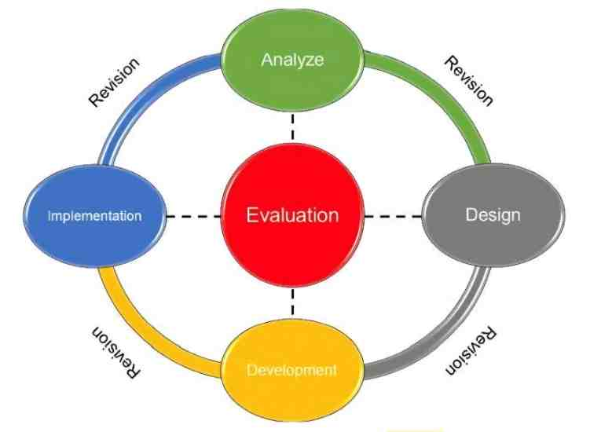

Figure 1. ADDIE Development Model

At the analysis stage, the researcher identified the learning needs in grade V of elementary school. This step includes literature studies, material observations, and brief interviews with several teachers to find out the actual challenges in delivering material on the digestive system. Information from teachers is the foundation in contextual media design. The next stage is design, which includes drafting concept maps, creating storyboards, and selecting supporting software such as Adobe Illustrator and Articulate Storyline 3. The development stage is carried out by combining visual elements (illustrations, animations), audio, and interactive practice questions to create a comprehensive learning experience. At the implementation stage, the media was individually tested by two experts—each from the field of material and learning media—as well as two peers. They provide input through validation sheets and questionnaires. The final stage is evaluation, where improvements are made based on the feedback obtained. The data collection technique uses a questionnaire instrument, which is then analyzed descriptively to determine the feasibility of the product. The analysis was carried out by calculating the percentage of the level of validity and effectiveness of the developed media.
The subjects involved in the ExploreDigest media development validation process consisted of four people, namely; 1 expert in learning materials, with a S3 education in Science and experience teaching science at the elementary level for more than five years. 1 learning media expert, educated in S3 Educational Technology and active in the development of digital media for basic education. 2 colleagues (colleagues), namely grade V teachers in two different elementary schools and have experience using interactive media in learning. The selection of subjects is carried out purposively, taking into account their background of expertise and direct involvement in relevant educational practices. The data collection method in this study uses a questionnaire technique, with a data analysis approach in the form of qualitative descriptive analysis. The questionnaire instrument used contains responses collected from the assessment of learning material experts, learning media experts, and individual trials by peers. Data was collected using two types of instruments, namely validation sheets filled out by material experts and media experts to assess the feasibility of the content, display, and technical of the media. An individual trial questionnaire was given to two peers to obtain an assessment from the practical user perspective (teacher user perspective).
The instrument is compiled based on the indicators of the development of interactive learning media from references that have been conceptually validated. Before use, the instrument is validated by two expert lecturers in the field of technology education to ensure content validity. The reliability of the instrument was tested through an initial trial (pilot) using the Alpha Cronbach approach to 20 similar questionnaires outside the main sample. The test results showed a reliability coefficient value of 0.82, which was included in the high category. The collected data was analyzed using qualitative descriptive techniques. The assessment of each validator was converted into a feasibility percentage score and then the percentage results were classified into five categories of feasibility levels based on a five-scale conversion criterion, to determine whether the product is feasible, needs revision, or is not suitable for use.

RESULTS AND DISCUSSION
Research Results
Stages of Analysis
This research aims to develop an interactive media ExploreDigest designed to support the learning process of human digestive system material in the content of science lessons in grade V elementary school. At the analysis stage, an analysis will be carried out on the needs of learning media and learning materials. The analysis stage began by conducting a brief interview with several teachers about the need for interactive media in the human digestive system. The results of interviews with several teachers are the challenges faced by grade V elementary school students when gaining a deeper understanding of the human digestive system. Some teachers believe that studying the human digestive system is important. In addition to playing a role in encouraging the development of science literacy, this learning also contributes to improving students' health literacy so that they are more selective in sorting and choosing foods to be processed in the body. Furthermore, the teacher also revealed that most students understand the basic functions of the organs in the digestive system, but are not yet able to analyze the entire digestive process. This is evidenced by the low grade assessment, as well as the lack of student participation during class discussions and the difficulty of students connecting theory with the specific functions of each organ and fostering critical thinking on the material. Then the teacher also stated that several times students had difficulty recognizing the relationship between organs in the digestive process and understanding the concept of food metabolism in its entirety. From the results of brief interviews with several teachers and from the results of previous research, teachers must be able to present an interactive and real-situation-based learning approach to be able to provide a pleasant learning atmosphere. Therefore, a more contextual learning approach is needed and in accordance with the characteristics of students' learning needs accompanied by the use of interactive and innovative media. Interactive media will provide detailed visualization and an applicable learning experience so that students can understand the digestive process more realistically and directly.
Planning Stage
In the design stage, it begins with creating a concept map and storyboard which will later be available in ExploreDigest media. The concept map in question is a menu structure that can be accessed in the application, as well as a guide for the next stage. ExploreDigest's interactive media consists of the Materials, Simulations, and Exercises menus. The following menu structure that has been designed can be observed through the figure 2.
In creating this media, 2 software will be used, namely Adobe Illustrator to create illustrations such as backgrounds, title text and also create supporting icons, and use Articulate Storyline 3 software for overall media creation, such as inserting content, animated videos, and so on. After creating a concept map or menu structure on interactive media, a storyboard is prepared on the ExploreDigest interactive media. Storyboards contain sketches or visual plans of interactive learning media that are used as a reference by graphic design. The preparation of the storyboard using the Articulate Storyline 3 software begins with the creation of the main page consisting of learning materials, simulations or illustrations, and practice questions.
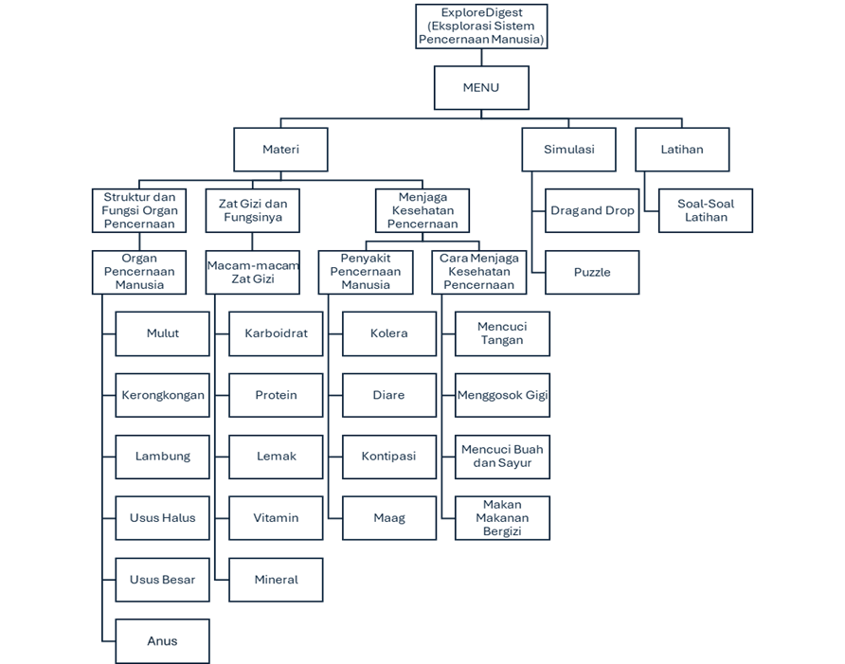
Figure 2. ExploreDigest Media Menu Structure

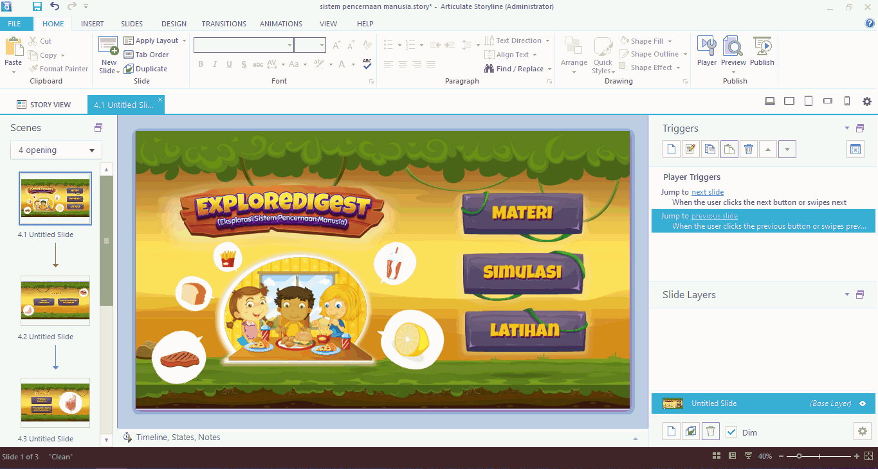
Figure 3. ExploreDigest Media Storyboard Creation with Articulate Storyline 3 Software

Development Stage
The third stage is the development stage where the creation of ExploreDigest interactive media is carried out. At the stage of media development, this is carried out in stages and structured referring to concept maps and storyboards that have been planned beforehand. The media development process begins with creating a background that is applied in the media. In addition, the development team will create various product navigation elements that include buttons used on media that will make it easier for users to explore the content of the media. Furthermore, the creation of game assets that will be used in games or interactive content on the media. The background, navigation buttons and game assets that will be applied to the media are made as visually appealing as possible so that users feel comfortable using the media. All digital assets, namely backgrounds, buttons, game assets, icons and other supporting elements, are produced using Adobe Illustrator graphic design software. The following process of creating digital elements in ExploreDigest media using Adobe Illustrator software can be seen in the Figure 4.

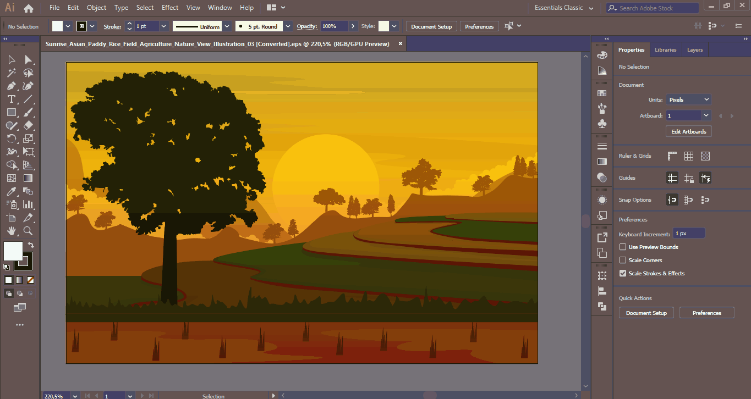
Figure 4. Creating Backgrounds Using Adobe Illustrator Software

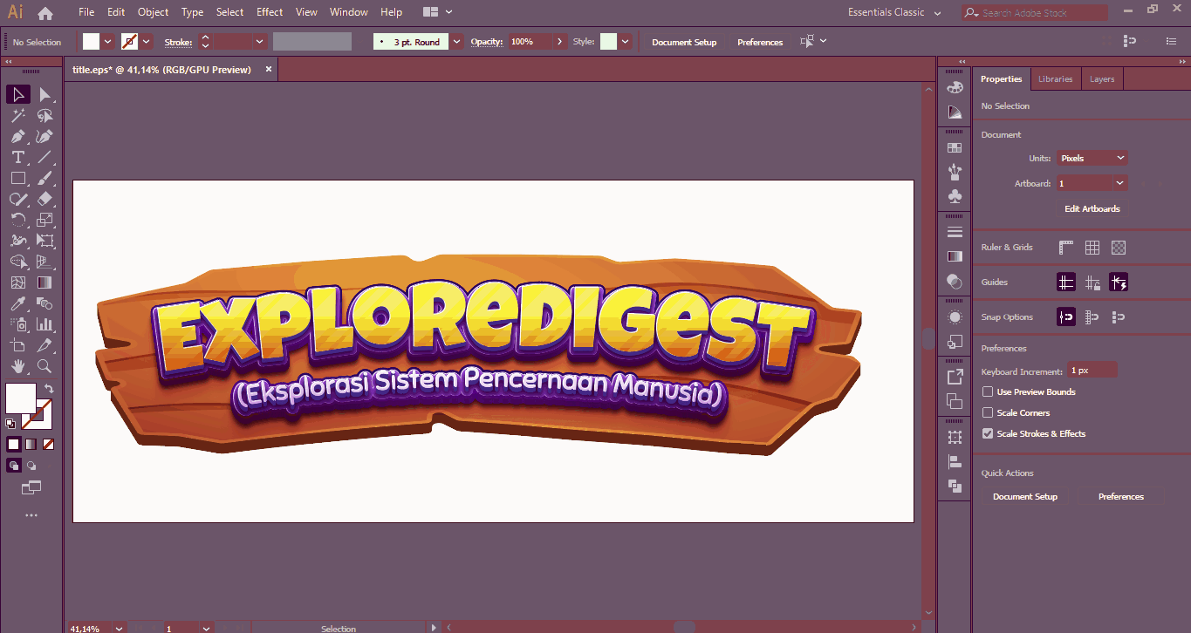
Figure 5. Creating Media Title Text Using Adobe Illustrator Software

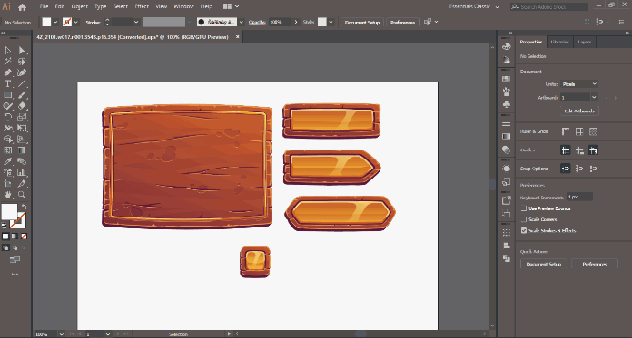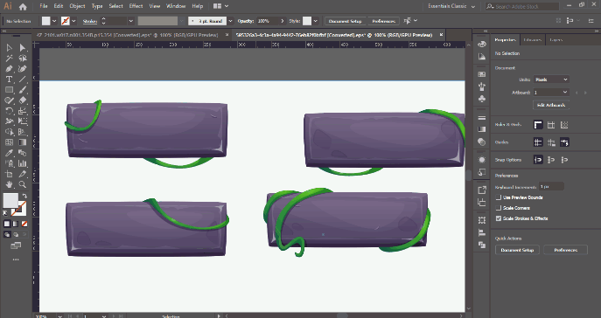
Figure 6. Creation of Game Assets in the form of Basic Boards and Buttons with Adobe Illustrator

After creating the background, title text and creating buttons and icons used in interactive media, followed by creating content and animated videos. At this stage of development, the entire process of creating ExploreDigest interactive media will be completed, including materials, practice questions, animated videos, images and supporting audio. The material on interactive media is also equipped with video animations and images to make them attractive and easy for students to understand. In the material section, there are 3 sub-sections consisting of the structure and function of the digestive organs, containing each of the constituent organs of the digestive system and its functions, nutrients and their functions, which contains the components of the food constituent substances and each function for the body, and the last is maintaining digestive health which explains several kinds of diseases that attack the digestive system, as well as ways that can be done to maintain the digestive system. In this part of the learning material, there will be several slides containing images that can then be selected and a dialog box will appear containing further explanations. There is also an explanation given in the form of a short animated video.

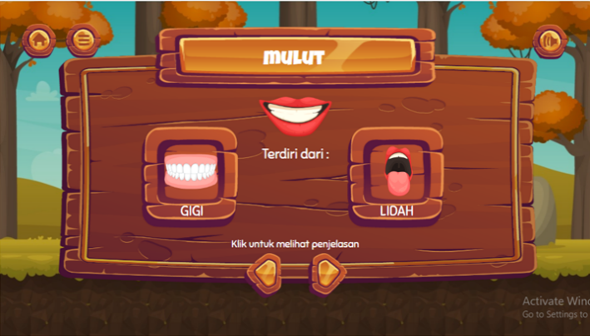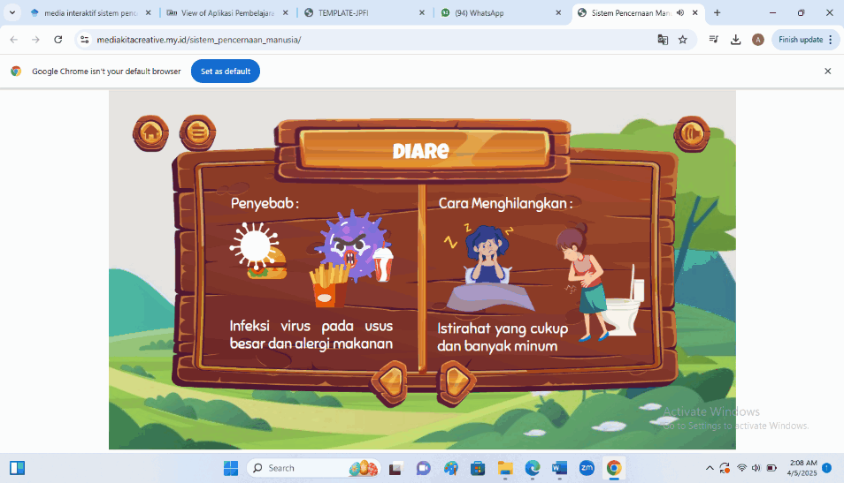
Figure 7. Process of Input Material into Media Using Articulate Storyline Software 3

On the Simulation menu, there is a mini quiz as an evaluation of students in understanding the material before doing the practice questions provided. The simulation menu contains drag and drop, which is to adjust and match the image of the digestive organ with its function correctly, as well as a puzzle to rearrange the pieces of the image correctly. There are 2 drag and drop slides, as well as 1 puzzle slide. Students cannot go to the next page if they have not answered the questions. At the end of the simulation part will be displayed the student's answer score.

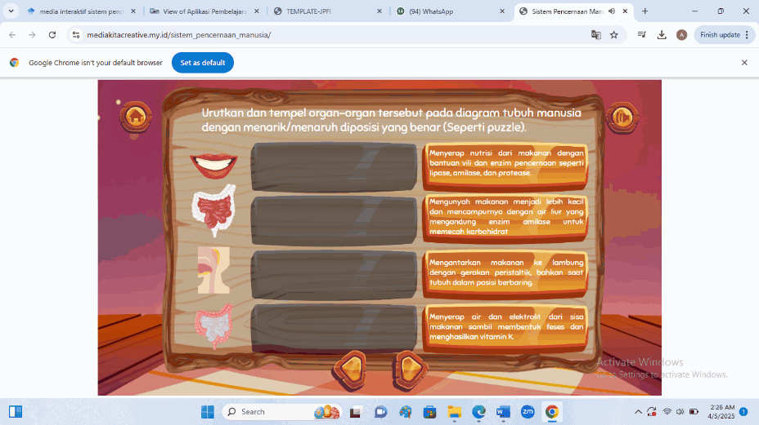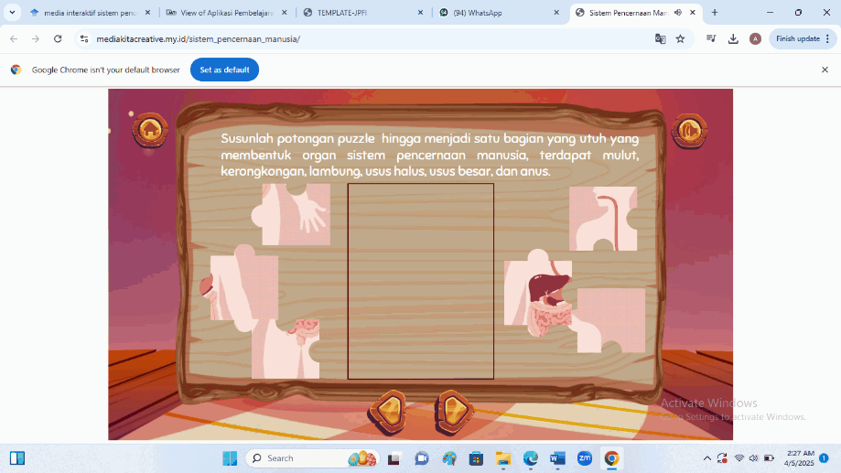
Figure 8. User Interface Display on the Simulation Menu

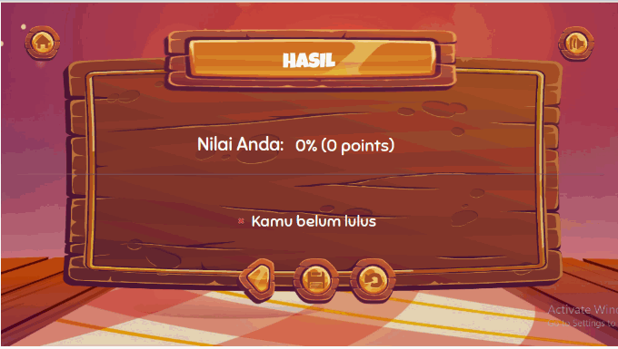
Figure 8. User Interface Display of Value Results on the Simulation Menu

On the practice menu, students are given 10 multiple-choice questions, students cannot continue to the next page if they have not filled in the answers. After students fill in the answers, they are immediately given a response by the media whether the answer is correct or wrong. In addition, an explanation will also be given regarding the correct answer. At the end of the section, after students answer 10 questions, the results of the scores obtained will come out.

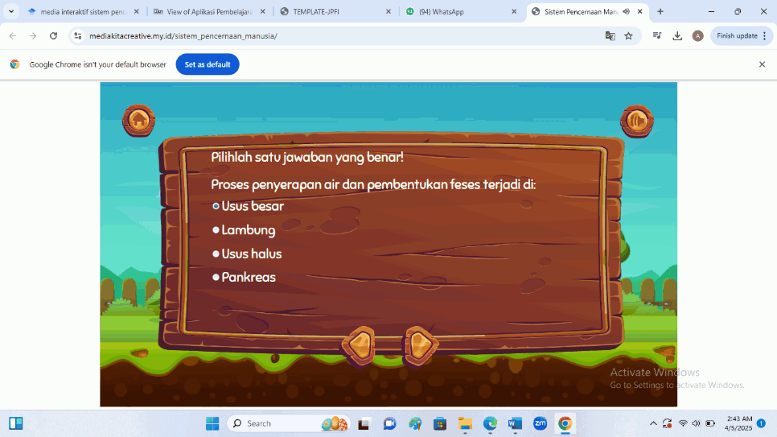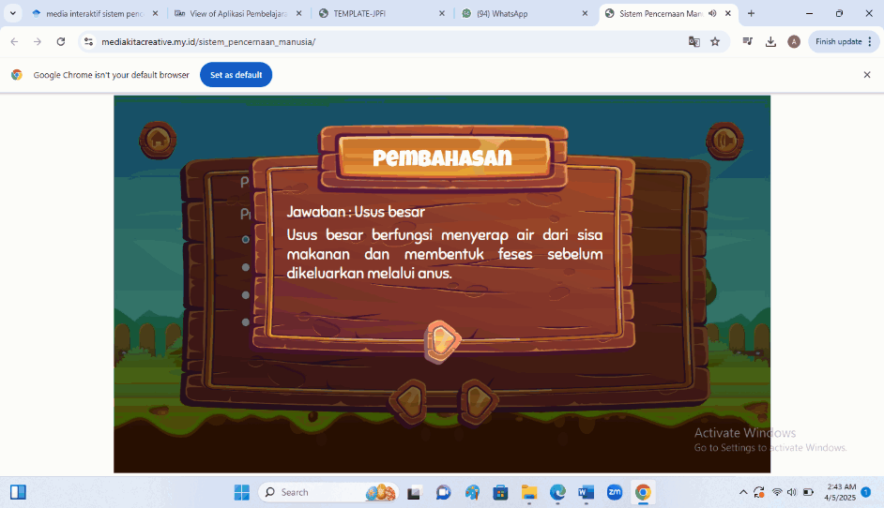
Figure 9. User Interface Display in the Practice Menu

Implementation Stage
The next stage is implementation or implementation which is an important stage in product validation and refinement. At the implementation stage in this study, the evaluation process was carried out to determine the feasibility and effectiveness of the interactive multimedia product that has been developed, namely ExploreDigest. This implementation process involves two types of assessments, namely validation by experts and individual trials by peers. First, ExploreDigest products are validated by two validators who have competence in their fields. The first validator is an expert in learning content or material with a S3 Science education background and has more than 5 years of experience teaching Science at the basic level. Learning content validators are responsible for assessing the feasibility of the content and the suitability of the content for the learning objectives. The second validator is a learning media expert with a S3 education in Educational Technology and is active in the development of digital media for basic education, which focuses on the design, technical, and interactivity aspects of the developed media. The two validators provided constructive input by filling out an assessment questionnaire, which aimed to assess the quality and effectiveness of learning media as a whole. In addition to validation by experts, individual trials were also carried out on two colleagues, who are grade V elementary school teachers who have experience in the use of interactive media in learning. These two colleagues will be asked to use the product directly and provide feedback on their experience. This feedback from peers serves to provide additional perspective from the user side and detect potential flaws that may not be detected by expert validators. To quantify responses, a Likert scale was used, and feasibility was calculated using percentage scores. The material expert gave a score of 85.4%, while the media expert gave 84.3%—both indicating "good" with minor revisions needed. The peer review by teachers produced a score of 90%, categorized as “very good.”
Evaluation Stage
The development stage of the ADDIE model multimedia ended with an evaluation as the fifth stage. Evaluation is a stage to find out the accuracy of a multimedia product, both the success and the difficulties experienced when using the media that has been designed. The assessment is carried out as the basis for evaluation, which involves the participation of material experts, media experts and responses from peers in the individual media test. Learning material experts gave a score of 85.4% which when viewed in the conversion table, the achievement rate means that the media is good and only needs a little revision. The response submitted by the learning material expert was to increase the number of visually interesting materials, namely with images and animated videos. The material included is also in accordance with what is needed, and the practice questions are also in accordance with the material available in the media. Learning media experts gave a score of 84.3% which means that the learning media is good and needs a little revision. Some suggestions as well as corrections from learning media experts are paying attention to the font size so that children can read it clearly, correcting the command words in the simulation, and sorting learning objectives according to the bloom taxonomy. In the individual test by peers, a score of 90% was achieved. In the conversion rate, the achievement rate means that the media is already very good and does not require revision. Some of the comments given by respondents are that very interesting media can increase students' motivation to learn. The choice of colors and backgrounds is good, the selection of images and animated videos is also good. The media can be used anywhere and anytime, so it can be used repeatedly. The use of media must be accompanied by a good network so that interactive media can be accessed.

Discussion
The product developed in this study is an interactive multimedia called ExploreDigest, which is designed to present material on the human digestive system for elementary school grade V students. This media has an attractive and interactive visual display, aiming to encourage motivation and increase students' enthusiasm for learning anytime and anywhere. This product is designed based on the principles of Instructional Design and Multimedia Learning theory by Mayer (2009), which emphasizes the importance of combining text, visuals, and audio in enhancing meaningful concept understanding. Interactive media allows students to interact directly with the material through animations and narratives that support contextual learning. The features in ExploreDigest are designed to match the cognitive characteristics of elementary school students. The right combination of media elements also facilitates the process of internalizing complex science concepts. With this approach, students not only memorize, but also build a deeper understanding. In addition, this media is able to answer the challenges of teachers in delivering abstract and scientific science material. By utilizing technology, ExploreDigest also supports a flexible learning process, which can be used in various conditions, both online and offline (Safira & Nahdi, 2024). Therefore, ExploreDigest is an innovative alternative that is relevant to the learning needs of 21st century science.
The use of interactive media in science learning is very much in line with the vision of national development in the field of continuing education. This supports the Sustainable Development Goals (SDG) 4 agenda, which emphasizes the importance of quality education that is equitable, inclusive, and accessible throughout life (Sihombing et al., 2024). In this context, interactive media plays a role as a tool that improves the quality of learning through the presentation of interesting and non-monotonous content. Fun and contextual education is key in encouraging students' active participation. The integration of technology in learning also answers the needs of the digital generation who are more familiar with visual and interactive media. Teachers are required to be creative in choosing and developing media that can arouse students' interest in learning. Therefore, the presence of ExploreDigest is an innovative solution that is able to support the achievement of SDG 4 indicators in concrete terms in primary education units. This media also shows that technology-based education is not only a necessity in the pandemic era, but has become part of the modern learning system. With the support of valid, representative, and adaptive content, this media is a means to present subject matter more effectively (Putra & Murniati, 2023). ExploreDigest is a tangible form of synergy between technological innovation and the vision of sustainable education.
The role of teachers in creating conducive and productive learning greatly determines the success of media use. Teachers must be able to increase student learning activities, especially in terms of active participation in the classroom (Simatupang et al., 2022). Interactive learning media is an important strategy to bridge the limitations of delivering science materials that tend to be complex. Using ExploreDigest, students can visually see illustrations of the digestive system and listen to audio explanations. This combination makes it easier for students to understand the flow of the digestive process systematically. In addition, this media also provides quiz activities that trigger student involvement and reflection on the material that has been learned. The learning atmosphere becomes more lively, dynamic, and fun. Teachers can use this media as a means to build active and in-depth discussions (Rambung et al., 2023). Thus, this media is not only a learning aid, but also encourages pedagogical transformation to be more participatory. The use of interactive media like this is the right strategy in answering the challenging science learning needs.
Based on the results of the validation of material experts, ExploreDigest obtained a score of 85.4%, which indicates that this medium is declared in the good category. The material presented was in accordance with the basic competencies of science subjects in grade V elementary school. The presentation of the concept of the human digestive system is carried out systematically, completely, and relevant to learning outcomes. Explanations use communicative language, in accordance with the thinking skills of elementary school students. In addition, the illustrations shown support students' understanding in recognizing parts of the digestive organs and their functions. This media also displays narratives that are educational but still light and easy to understand. This is very helpful for teachers in explaining the material more efficiently. Students are not only listeners, but also active participants in the learning process. Content validation by experts proves that this medium is not only feasible to use, but also able to answer the needs of the curriculum. This makes ExploreDigest a learning medium that complies with national pedagogical and curriculum standards.
The assessment from media experts showed very positive results, with a score of 84.3% which was classified as good. In terms of visual appearance, ExploreDigest media stands out with an attractive design and in accordance with the characteristics of elementary school-age students. The use of bright colors and intuitive icons supports a fun learning atmosphere. Validators provide feedback to make transitions between pages smoother to improve ease of use. All multimedia elements such as text, images, animations, and audio have been well integrated. This is in line with the principles of contiguity and coherence in Sopiah et al. (2023) which states that media elements must be presented in harmony to be effective in conveying messages. Navigation features such as buttons and menus are easy for students to understand. The presence of a simple quiz feature at the end of the session strengthens student engagement and measures their understanding of the material. This medium is designed not only to be watched, but to be actively explored by students. This validation is proof that from a design perspective, ExploreDigest has met the usability and user engagement criteria.
In the individual trial stage, ExploreDigest media scored 90%, which indicates the category is excellent. Respondents stated that this medium is very interesting and fun to use by students in studying the human digestive system. The animation features and sound effects make learning more lively and less boring. Students show high enthusiasm when using this medium in the learning process. They are more likely to understand concepts than when using conventional lecture methods (Evalina et al., 2024). In addition, the time of media use is in accordance with the allocation of science lesson time in elementary schools. Respondents also mentioned that this media is flexible because it can be used online or offline. Media can be accessed through digital devices such as laptops, tablets, and smartphones, making it easier to use in various infrastructure conditions (Handayani, 2021). Students can learn independently at home or with teachers in the classroom. As such, ExploreDigest fulfills the principles of flexibility, accessibility, and effectiveness in learning.
ExploreDigest's interactive multimedia products are developed with a contextual approach and aligned with the basic competencies in the national curriculum. This answers criticism of learning media that is often not in accordance with the local context or characteristics of students. Unlike passive media that only displays one-way information, ExploreDigest presents active and participatory learning. This media combines powerful visualization, communicative narrative text, and explanatory audio that supports multimodal learning. The content presented is relevant to students' daily experiences so that it is easier to understand and internalize (Jannah & Oktaviani, 2022). Another advantage is the ability of this media to be used in various regions, including areas that are not yet fully digital. The use of offline and online makes this media adaptive to diverse infrastructure conditions. In addition, this media is also designed as a means of independent learning that students can access flexibly. An approach like this is a concrete solution in the equitable distribution of education quality (Solihin et al., 2024). Therefore, ExploreDigest is a learning media that is applicable, contextual, and oriented to student needs.
The findings in this study are reinforced by various previous studies that show that interactive media encourages students to become active learners, not just passive listeners (Suryanti et al., 2021). Technology-based learning has been proven to be able to improve cognitive, affective, and psychomotor learning outcomes. ExploreDigest provides a fun and meaningful learning experience, according to the characteristics of elementary school students. With a strong theoretical approach and convincing empirical validation, this medium is worthy of widespread implementation. In addition, its integration with modern learning principles and educational sustainability makes this product more than just a learning aid. ExploreDigest can be an innovative and effective science learning solution in the digital age. The support of various parties is needed to develop this media more widely and sustainably (Iskandar & Mayarni, 2022). The potential of this media to support learning achievement is enormous if it continues to be refined and distributed massively. This medium can also be adapted for other subject matter with similar design principles. Thus, ExploreDigest is not only innovative, but also inclusive and transformative for primary education in Indonesia.

CONCLUSION
This research succeeded in developing the interactive multimedia product ExploreDigest as a science learning medium on human digestive system materials for grade V elementary school students. Based on the results of validation by material experts and media experts, as well as individual trials, this media is stated to be very suitable for use because it has an attractive appearance, valid content, and interactive features that can increase student motivation and understanding. The advantage of this media lies in the integration of text, visuals, animation, and audio that is in accordance with multimedia learning theory and 21st century learning needs. This media also supports a flexible learning process, both online and offline, so that it is suitable to be applied in various school infrastructure conditions. In addition, ExploreDigest provides an active and enjoyable learning experience for students, as well as assisting teachers in delivering complex material more easily and efficiently. For further development, it is recommended that ExploreDigest be equipped with an automatic evaluation feature so that teachers can directly monitor student learning outcomes digitally. In addition, it is important to conduct small-group and large-group trials so that the effectiveness of these media can be analyzed more thoroughly. This media also has the potential to be developed in the form of an Android-based application so that its accessibility is wider. In the future, developers are advised to adapt this media to the needs of inclusive students or special needs, so that the principles of inclusive learning can be achieved. In addition, collaboration with schools and education offices is very important so that this media can be implemented more widely in the science learning curriculum in elementary schools.

REFERENCES
Aminah, A., Hairida, H., & Hartoyo, A. (2022). Penguatan Pendidikan Karakter Peserta Didik melalui Pendekatan Pembelajaran Kontekstual di Sekolah Dasar. Jurnal Basicedu, 6(5). https://doi.org/10.31004/basicedu.v6i5.3791
Andini, N. P. M. (2022). Pengembangan Multimedia Interaktif berbasis Pendekatan Saintifik dalam Pembelajaran Sistem Pencernaan Manusia Kelas V SD. Jurnal Media dan Teknologi Pendidikan, 2(1). https://doi.org/10.23887/jmt.v2i1.44839
Branch, R. M., & Varank, İ. (2009). Instructional design: The ADDIE approach (Vol. 722). Springer.
Dhaniawaty, R. P., Suci, A. L., & Hardiyana, B. (2021). Aplikasi Pembelajaran Multimedia Interaktif Mata Pelajaran IPA Mengenai Sistem Pencernaan Manusia Untuk Siswa SMP Kelas VII. Jurnal Teknologi dan Informasi, 11(2), 183–194. https://doi.org/10.34010/jati.v11i2.5574
Duha, M. H. (2024). Pengembangan Multimedia Interaktif Biologi Berbasis Online untuk Materi Sistem Pencernaan Manusia di SMA Negeri 1 Teluk Dalam. TUNAS : Jurnal Pendidikan Biologi, 5(1), 85–97. https://doi.org/10.57094/tunas.v5i1.1815
Evalina, E., Wulandari, N., & Suryawan, A. (2024). Implementasi Problem Based Learning Berbantuan Media Pembelajaran Inovatif untuk Meningkatkan Literasi Sains Siswa Sekolah Dasar. SEMNASFIP.
Evasari, S., & Erlianti, D. (2022). Analisis Asas Pelayanan Publik pada Kantor Desa Sungai Cingam Kecamatan Rupat Kabupaten Bengkalis. Jurnal Administrasi Publik dan Bisnis, 4(1), 39–49. https://doi.org/10.36917/japabis.v4i1.43
Handayani, T. (2021). Pengembangan media komik digital berbasis STEM untuk meningkatkan literasi sains siswa sekolah dasar. Jurnal Didaktika Pendidikan Dasar, 5(3), 737–756.
Hsiao, P.-W., & Su, C.-H. (2021). A study on the impact of steam education for sustainable development courses and its effects on student motivation and learning. Sustainability (Switzerland), 13(7). https://doi.org/10.3390/su13073772
Iskandar, M. F., & Mayarni, M. (2022). Pengembangan Media Augmented Reality pada Materi Pengenalan Planet dan Benda Langit Pembelajaran IPA Sekolah Dasar. Jurnal Basicedu, 6(5), 8097–8105. https://doi.org/10.31004/basicedu.v6i5.3730
Jannah, R., & Oktaviani, R. N. (2022). Pengaruh penggunaan media augmented reality terhadap kemampuan literasi numerasi digital pada pembelajaran matematika materi penyajian data kelas V MI At-Taufiq. Jurnal Ibriez: Jurnal Kependidikan Dasar Islam Berbasis Sains, 7(2), 123–138.
Manurung, P. (2020). Multimedia Interaktif Sebagai Media Pembelajaran Pada Masa Pandemi Covid 19. Al-Fikru: Jurnal Ilmiah, 14(1), 1–12.
Mayer, R. E. (2009). Multimedia Learning. Cambridge University Press. https://doi.org/10.1017/CBO9780511811678
Novitasari, D., & Kurniawati, R. (2023). Optimalisasi Pengalaman Belajar Siswa SD melalui Media Pembelajaran Interaktif Berbasis Web. Nusantara Educational Review, 1(1), 43–55.
Putra, D. P., & Murniati, M. (2023). Media pembelajaran berbasis steam: membantu mengembangkan keterampilan anak. Jurnal Pelita: Jurnal Pembelajaran IPA Terpadu, 3(2), 83–100.
Rambung, O. S., Sion, Bungamawelona, Puang, Y. B., & Salenda, S. (2023). Transformasi Kebijakan Pendidikan Melalui Implementasi Kurikulum Merdeka Belajar. Jurnal Ilmu Pendidikan, 1(3), 598–612. https://jip.joln.org/index.php/pendidikan/article/view/63
Safira, R. F., & Nahdi, D. S. (2024). Keragaman Perangkat Lunak Multimedia Interaktif Untuk Meningkatkan Kualitas Pembelajaran IPA Sekolah Dasar. JURNAL MADINASIKA Manajemen Pendidikan dan Keguruan, 5(2), 68–77.
Sihombing, R. A., Muslim, M., & Agustin, M. (2024). Pemanfaatan Buku Ajar Elektronik Interaktif Untuk Pembagunan Berkelanjutan Sebagai Solusi Dalam Meningkatkan Kesadaran Berkelanjutan Siswa SMP. Jurnal Penelitian Sains dan Pendidikan (JPSP), 4(2), 134–147.
Simatupang, H., Siregar, E. H., Sihombing, R. A., & Tanjung, M. Y. (2022). Profile of Technology Pedagogical Content Knowledge-21 (TPACK21) on Pre-Service Science Teacher in Microteaching Course.
Solihin, A., Choirunnisa, N. L., & Mintohari, M. (2024). Eksplorasi Etnosains Monumen Kapal Selam Surabaya Sebagai Sumber Belajar IPAS Sekolah Dasar. Jurnal Review Pendidikan Dasar: Jurnal Kajian Pendidikan dan Hasil Penelitian, 10(2), 137–148. https://doi.org/10.26740/jrpd.v10n2.p137-148
Solihin, A., Kristanto, A., Gunansyah, G., Daoyi, Z., & Sijia, S. (2024). e-ScoutHix: Transforming Scouting Education in Junior High School through AI and Cultural Integration for Sustainable Character Development. Educative: Jurnal Ilmiah Pendidikan, 2(3), 148–159. https://doi.org/10.70437/educative.v2i3.812
Solihin, A., Rachmadyanti, P., & Setiawan, R. (2024). Rancang Bangun Vis.Map Berbasis Engklek Sebagai Media Eksistensi Kearifan Lokal Dalam Fase Digitalisasi di Era Gen Z: Studi Kasus Sekolah Dasar. Publikasi Pendidikan, 14(2), 213. https://doi.org/10.26858/publikan.v14i2.63540
Sopiah, P., Nugraha, M. F., & Nurfitriani, M. (2023). Pengaruh Media Pembelajaran Kartu Gaple Orpedama Terhadap Hasil Belajar IPA Siswa Kelas 5 Sekolah Dasar. 3(2), 378–389. https://unu-ntb.e-journal.id/pacu/article/view/440
Suryanti, A., Putra, I. N. A. S., & Nurrahman, F. (2021). Pengembangan Media Pembelajaran Energi Alternatif Berbasis Multimedia Interaktif. Jurnal Teknologi Pembelajaran Indonesia, 11(2), 147–156. https://doi.org/10.23887/jurnal_tp.v11i2.651
Syamsuar, S., & Reflianto, R. (2019). Pendidikan dan Tantangan Pembelajaran Berbasis Teknologi Informasi di Era Revolusi Industri 4.0. E-Tech : Jurnal Ilmiah Teknologi Pendidikan, 6(2). https://doi.org/10.24036/et.v2i2.101343
Syavira, N. (2021). Pengembangan Media Pembelajaran Berbasis Powerpoint Interaktif Materi Sistem Pencernaan Manusia untuk Siswa Kelas V SD. OPTIKA: Jurnal Pendidikan Fisika, 5(1), 84–93. https://doi.org/10.37478/optika.v5i1.1039
Tatema Harefa, A., Pebriani, E., Agus Rukiyanto, B., & Sabur, F. (2023). Pemanfaatan Teknologi dalam Menunjang Pembelajaran: Pelatihan Interatif dalam Meningkatkan Kualitas Pendidikan. Communnity Development Journal, 4(6).

